Pupil premium strategy statement
November 2023 - November 2026
Review date: July 2024

School overview
Detail | Data
School name | Brookhurst Primary School
Number of pupils in school | 412
Proportion (%) of pupil premium eligible pupils | 12% (51 pupils)
Academic year/years that our current pupil premium strategy plan covers | 2 years
Date this statement was published | December 2024
Date on which it will be reviewed | December 2025
Statement authorised by | Angela Stanton  Head Teacher
Pupil premium lead | Megan Sheffield
Funding overview
Detail | Amount
Pupil premium funding allocation this academic year | £78,310
Recovery premium funding allocation this academic year | Withdrawn
School-led Tutoring Grant | National funding ended 2023-2024
Pupil premium funding carried forward from previous years (enter £0 if not applicable) | £0
Total budget for this academic year | £78,310

Part A: Pupil premium strategy plan

Statement of intent
Our mission statement:
“Who you will be tomorrow starts with us today
Brookhurst is built around community, striving for excellence in all we do within a nurturing and sustainable environment.
We encourage self-belief and develop strength of character empowering us all to be the best we can be.
Ultimately, Brookhurst prepares our children for the next stage of their lives and enables them to achieve their dream.”
Grow with us today on your individual adventure.”

We aim to ensure that all of our strategies to support disadvantaged pupils are in line with our mission statement and will help to prepare children become lifelong learners.
We recognise the importance of considering the context of the school and the subsequent challenges made. We will use the three-tiered approach recommended by the EEF which is: high quality teaching, targeted support and wider strategies.
Although there are common barriers to learning for disadvantaged pupils such as lack of confidence, resilience and attendance issues, we recognise that the challenges are varied and there is no ‘one size fits all’.
As recognised by the EEF we acknowledge that ‘good teaching is the most important lever schools have to improve outcomes for disadvantaged students’. We will further develop our First Quality Teaching through focused CPDL for our Teaching Team.
The key principles of our strategy:
- Disadvantaged pupils are provided with opportunities for enrichment to ‘level the playing field’ (equity)
- Mental health and well-being are improved for all pupils
- High quality teaching
- Decisions about progress and attainment are based on forensic analysis of data and use of diagnostic tools to support individual pupils
Whilst our strategy adopts the recommended EEF tiered approach we recognise that it will, inevitably, vary from year to year as the schools and children’s priorities change. We will focus on a small number of strategies that commensurate with our school development plan.

Challenges

This details the key challenges to achievement that we have identified among our disadvantaged pupils.
Challenge number | Detail of challenge
1 | Data-driven identification of gaps, analyse current attainment and progress, focussing on greater depth and specific barriers e.g. SEND, EAL and attendance for PP pupils.
2 | Engagement with families - Build stronger relationships with families to understand barriers outside school and assist with broadening experiences of PP pupils to build cultural capital.
3 | Tailored CPDL for staff leading to targeted classroom interventions to ensure staff are equipped to cater for PP children effectively we will embed high quality approaches to teaching and learning.
4 | Enhance well-being support, address emotional and mental health needs of PP pupils.

Intended outcomes
This explains the outcomes we are aiming for by our next review date, and how we will measure whether they have been achieved.
Intended outcome | Success criteria
To gain comprehensive understanding of PP attainment progress and barriers in order to develop clear actionable intervention plans tailored to identify needs. | - Increased proportion of PP pupils achieving GLD in writing, reading and maths.
To improve relationships and communication with PP families. Families to feel supported in accessing wider opportunities and increased participation with extra-curricular opportunities. | - Feedback from families through surveys, and pupil voice questionnaires. Increased uptake of PP pupils in extracurricular activities. Attendance records for family engagement events.
Enhanced staff confidence and skills in supporting PP pupils and implementing tailored interventions. | - All staff have attended relevant training.  - Iris Connect recordings demonstrate application of new strategies.  - Assessment show improved progress.  - Staff feedback, reflecting increased confidence and knowledge for supporting PP pupils in the classroom.
PP pupils report feeling safe and supported in school. They have improved emotional resilience and self-regulation resulting in a reduction of well-being related issues which affect attendance and behaviour. | - Improved attendance rates for PP pupils.  - Pupil voice surveys reflecting positive well-being indicators.  - Behaviour-tracking showing fewer incidents among PP pupils.

Activity in this academic year
This details how we intend to spend our pupil premium, recovery premium and school-led tutoring grant in 2023/24 to address the challenges listed above.
High Quality Teaching (Tier 1)
Budgeted cost: £78,310
Activity | Evidence that supports this approach | Challenge number(s) addressed
Identify gaps in learning through forensic analysis of formative and summative assessment. | PiXL provides high quality diagnostic tools, strategies and resources available through a digital platform. This is used for assessment, planning, interventions.  Benefits of PiXL  (PiXL) | 1
Promote and explicitly teach identified areas of development in SEMH (mental health and wellbeing) | Research stresses that Social and Emotional Learning is especially important for children from disadvantaged backgrounds who, on average, have weaker SEMH skills at all ages than other children.  Improving Social and Emotional Learning in Primary Schools (EEF) | 4
Teaching team plan for and develop a range of well-structured, collaborative learning opportunities for pupils | There is evidence that collaborative learning approaches may benefit those with low prior attainment by providing opportunities for pupils to work with peers to articulate their thinking, share knowledge and skills and address misconceptions through peer support and discussion.  Collaborative Learning Opportunities (EEF) | 3
Provide meaningful feedback to pupils which suits the needs of the learners and enables them to recognise their strengths and give them the information that they need to improve | There is evidence to suggest that feedback involving metacognitive and self-regulatory approaches may have a greater impact on disadvantaged pupils and lower prior attainers than other pupils.  Feedback (EEF) | 3
Provide opportunities for peer tutoring | Studies have shown that pupils who are low attaining typically receive additional benefits from peer tutoring. Peer-led tutoring approaches may help pupils to close gaps in their learning by offering targeted, peer-led support to consolidate within class learning, practice skills, and identify and overcome misconceptions.  Peer Tutoring (EEF) | 3,4
Deliver regular phonics provision in EYFS, KS1 and to those who will benefit in KS2 using ‘Little Wandle Letters and Sounds’ and other appropriate resources | Studies in England have shown that pupils eligible for free school meals typically receive similar or slightly greater benefit from phonics interventions and approaches. This is likely to be due to the explicit nature of the instruction and the intensive support provided.  Phonics (EEF) | 1,3
Attend National College webinars to undertake relevant CPD which supports improved understanding relating to the intended outcomes for all staff | The National College offers the opportunity to continue CPD, have high-quality and up-to-date CPD, whilst being able to access it remotely.  National College Testimonials | 3
Plan for and deliver a high quality, well-planned and relevant education which extends pupils’ knowledge and understanding whilst addressing identified gaps in learning | All evidence from the EEF acknowledges that high quality teaching is the most important tool schools have to improve outcomes for all pupils.  Improving Literacy in KS2 (EEF)  Improving Literacy in KS1 (EEF)  Improving Maths in KS2 (EEF)  Improving Maths in KS1 (EEF) | 3
Continue to implement ‘Little Wandle Phonics in order to:  Track progress and  provide consistent curriculum and technique across all years | Little Wandle Letters and Sounds is the fastest growing Department for Education-validated phonics programme, already supporting over 5,000 schools to teach every child to learn to read.  https://www.littlewandlelettersandsounds.org.uk/about-us/our-impact/ | 1

Targeted academic support (Tier 2)
Budgeted cost: TA Hours
Activity | Evidence that supports this approach | Challenge number(s) addressed
1:1 and small group support from Teaching Assistant Interventions | Well-evidenced teaching assistant interventions can be targeted at pupils that require additional support and can help previously low attaining pupils overcome barriers to learning and ​‘catch-up’ with previously higher attaining pupils.  Teaching Assistant Interventions (EEF)  Disadvantaged pupils may be more likely to be affected by higher school absence rates and lower attainment, on average, when compared to their more advantaged peers. This means disadvantaged pupils may be more likely to progress through school with gaps in their understanding, which will affect how quickly and easily they can acquire and connect new learning. | 1, 3
Small group tuition from Teaching Team | Studies in England have shown that pupils eligible for free school meals typically receive additional benefits from small group tuition.  Small group tuition approaches can support pupils to make effective progress by providing intensive, targeted academic support to those identified as having low prior attainment or at risk of falling behind.  Small Group Tuition | 1, 3
Targeted assessment and feedback from teacher | More targeted assessment and feedback may also support pupils to address misconceptions or overcome specific barriers to learning.  Targeted Support (EEF) | 1, 3
Class based teaching assistants work specifically with PP children on pre-teach/consolidation activities. | For pupils identified as having low prior attainment or at risk of falling behind, individualised instruction may allow the teacher to provide activities that are closely matched to a pupil’s attainment.  Individualised Instruction (EEF) | 1, 3
Wider strategies (Tier 3)
Budgeted cost: £78,310
Activity | Evidence that supports this approach | Challenge number(s) addressed
Students provided opportunities to participate in arts (drama, music, trip, dance) | Arts Participation | 2, 4
Regular Forest School sessions | Outdoor Adventure Learning | 2, 4
Students engage in regular and specialist Physical Activity | Physical Activity | 2, 4
Promote and actively engage parents (school forum, parents forum, SEN parents forum, workshops, parent consultations | Parental Engagement | 2
Engage with and promote health and wellbeing topics | Compass - Health and Wellbeing support for Warwickshire Families | 2, 4
Retain a ‘contingency fund’ for rapid response requests e.g. trips, wellies, appropriate clothes for trips | Based on our experiences and those of similar schools to ours, we have identified a need to set a small amount of funding aside to respond quickly to needs that have not yet been identified. | 1,2,3,4
Breakfast club | Nurture Groups | 2, 4

Total budgeted cost: £78,310

Pupil premium strategy outcomes
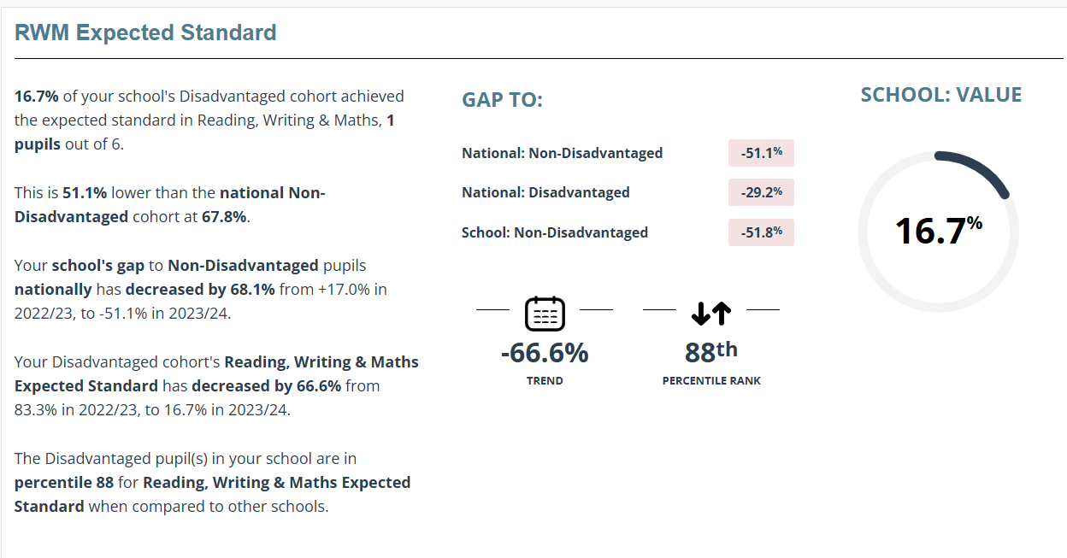
Key Stage 2 Outcomes 2023-2024

Reading, Writing
and Maths

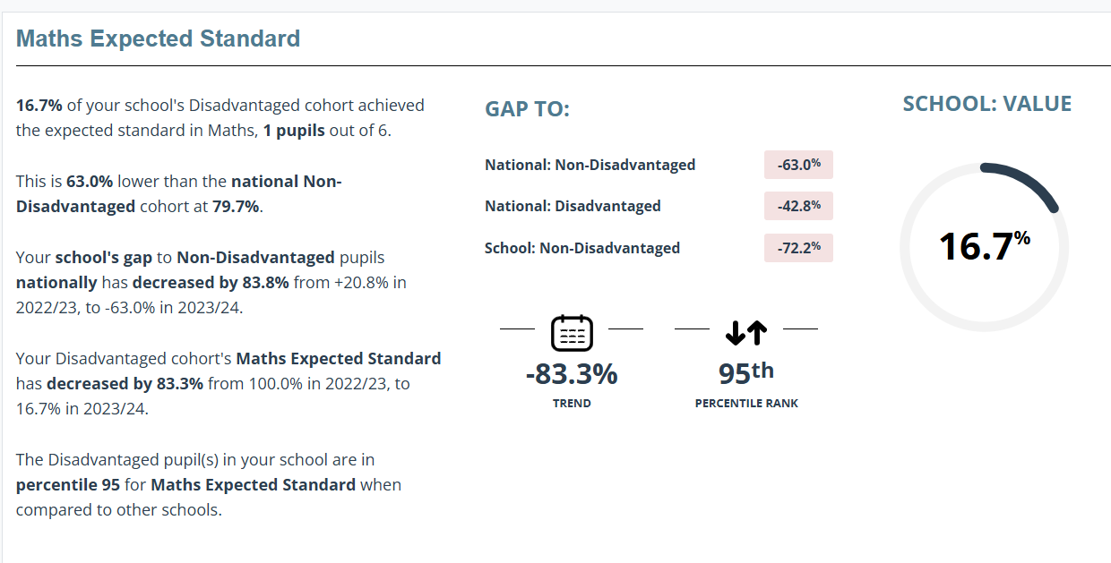

Maths

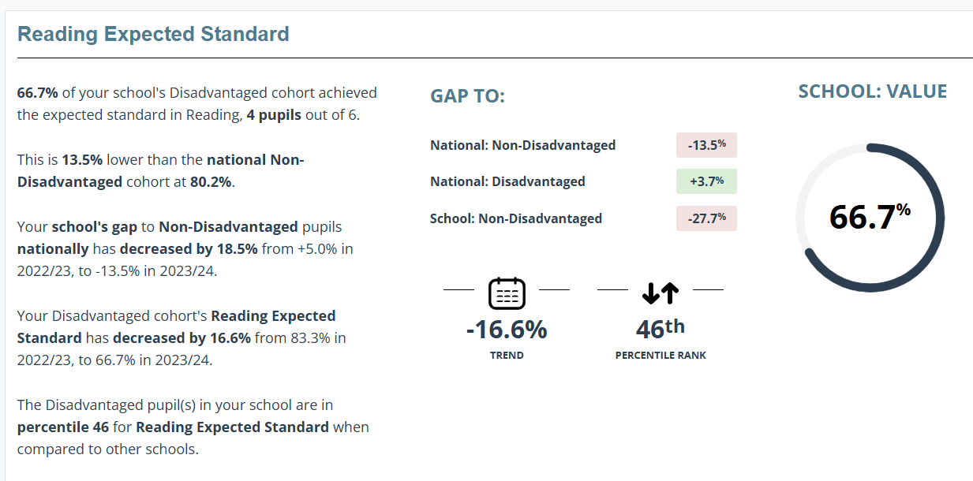

Reading

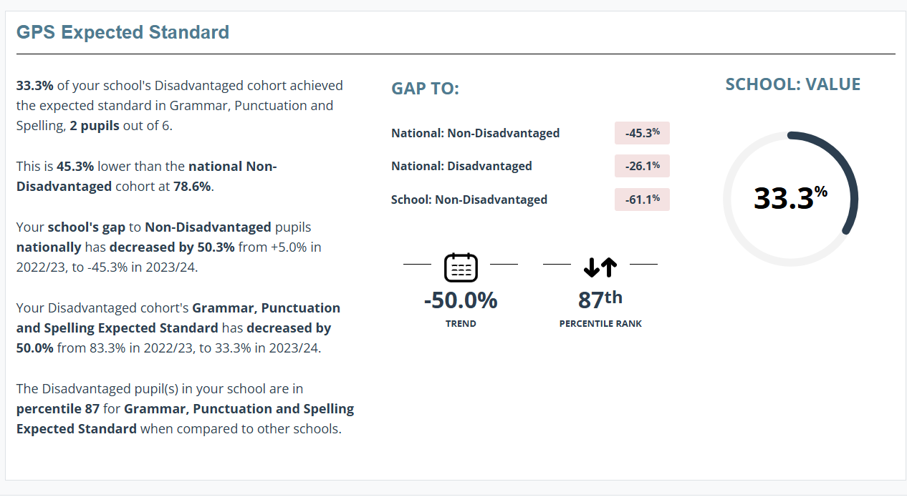

Grammar, Punctuation and Spelling

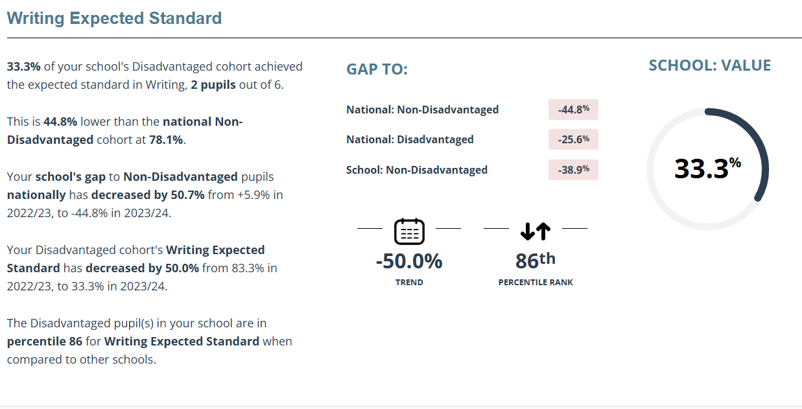

Writing

EYFS Outcomes 2023-2024
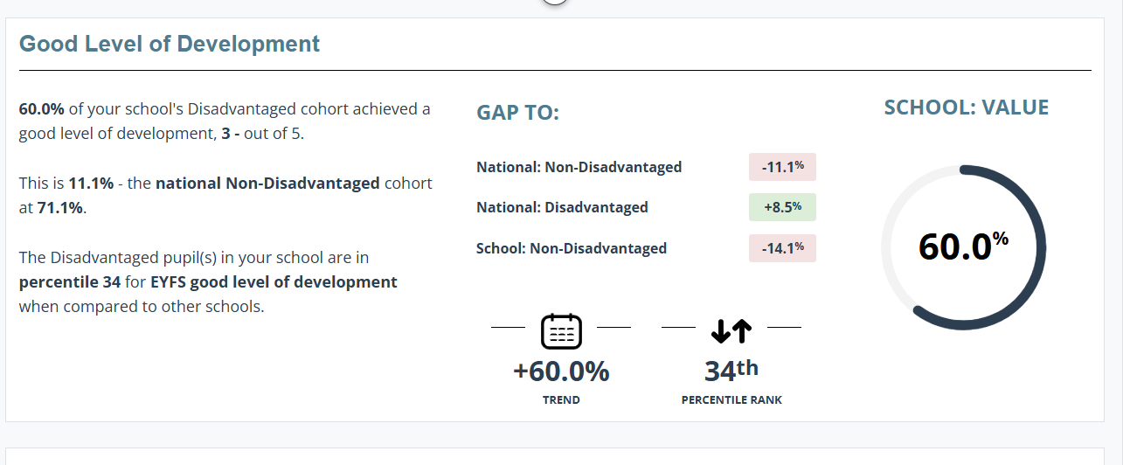

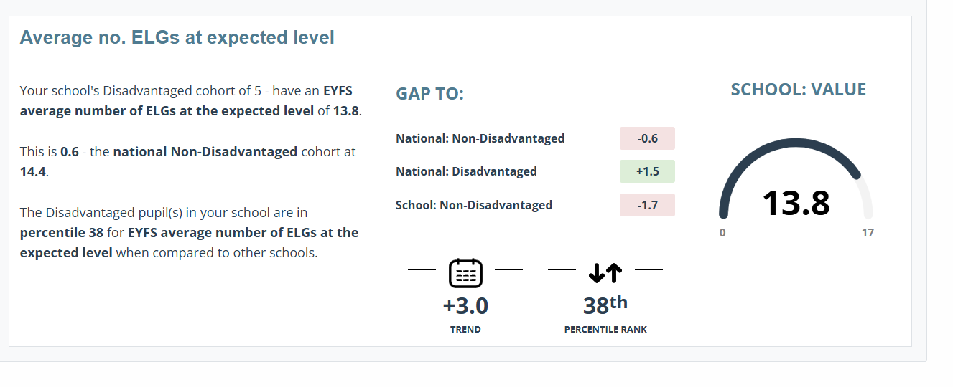

Phonics Outcomes 2023-2024
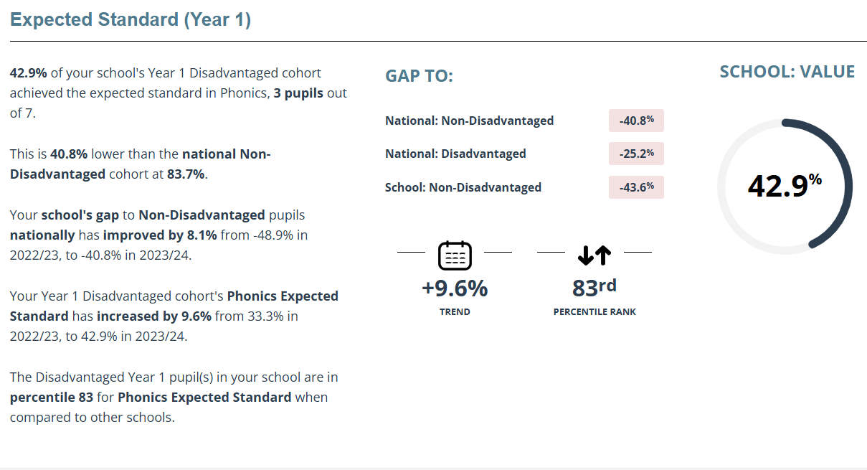

Year 1

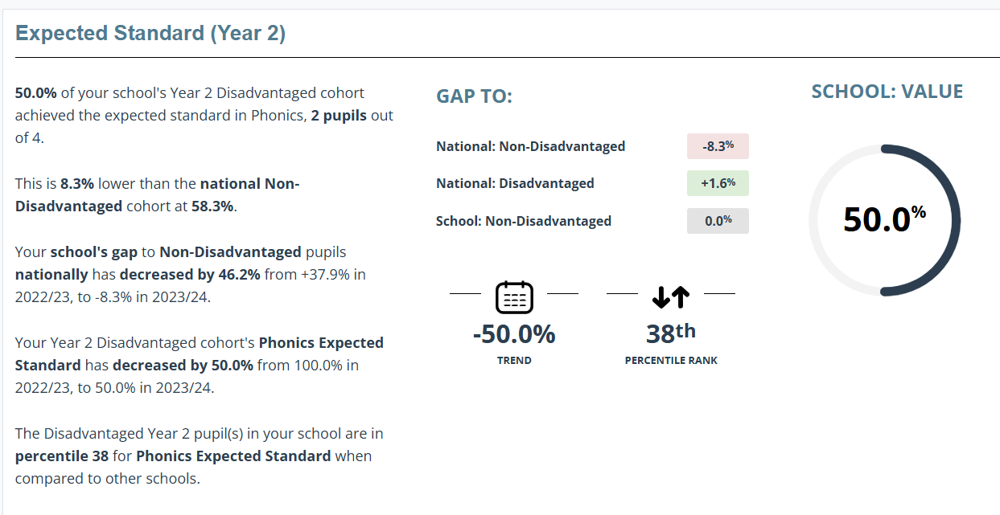

Year 2

KS2 outcomes from 2024 show that 67% of pupil premium children achieved the expected level in Reading, 33% of pupil premium children achieved the expected standard in Writing and GPS and 17% of pupil premium children achieved the expected standard in RWM and Maths.
EYFS outcomes from 2024 show that 60% of pupil premium children achieved GLD.
Phonics outcomes from 2024 show that in Year 1, 43% and in Year 2, 50% of pupil premium children achieved the expected standard in phonics.
Brookhurst Primary School Updated Pupil Premium Strategy Addendum 2024-2025
Based on our ongoing commitment to supporting disadvantaged pupils, this addendum outlines the latest updates to our strategy, incorporating the EEF guidance and promising programmes. Key Updates:
Embedding Promising Programmes
We are implementing the Maths Mastery approach across all year groups to enhance attainment outcomes for all pupils.
Enhanced Tracking and Accountability
The introduction of Provision Map software enables us to track individual pupil-level spending, ensuring transparency and targeted support. Targeted Academic and Pastoral Support
Interventions continue to focus on literacy and numeracy, providing basic skills catch-up for disadvantaged pupils.
Off-site provision is funded for pupils benefiting from alternative approaches to reintegration.
Support programmes include counselling, Lego therapy, physio programmes, rapid catch-up, and movement breaks. Pupil Enrichment Activities
Funding for extracurricular and enrichment activities tailored to individual needs, including emotional wellbeing and academic support.
Dedicated Staffing and Governance
Our Pupil Premium RSL drives our initiatives and monitors progress supported by the headteacher.
The Inclusion Governor uses EEF-challenging questions to ensure best practices are in place. Data-Driven Monitoring
Progress is monitored, at least, termly, with stretch and challenge activities tailored to individual pupils' needs. Professional Development and First-Quality Teaching
CPDL sessions are focusing on aligning behaviours and progress with best practices.
IRIS Connect is being integrated to enhance teaching staff's understanding of pupil behaviour and develop targeted interventions. High Aspirations for All
A no-exceptions policy ensures high aspirations and targeted support for all pupils, with pupil voice considered to tailor resources and interventions. This addendum complements the existing strategy and highlights our ongoing efforts to provide equitable and effective support for disadvantaged pupils throughout 2024-2025.
Angela Stanton Head teacher
Megan Sheffield Pupil Premium RSL
December 2024
To be reviewed December 2025

Externally provided programmes
Programme | Provider
PiXL | PiXL
Little Wandle | Little Wandle

